PROG USER MANUAL

Kgosi Olifant

ST10384317

# Home Window

When the user Launches the 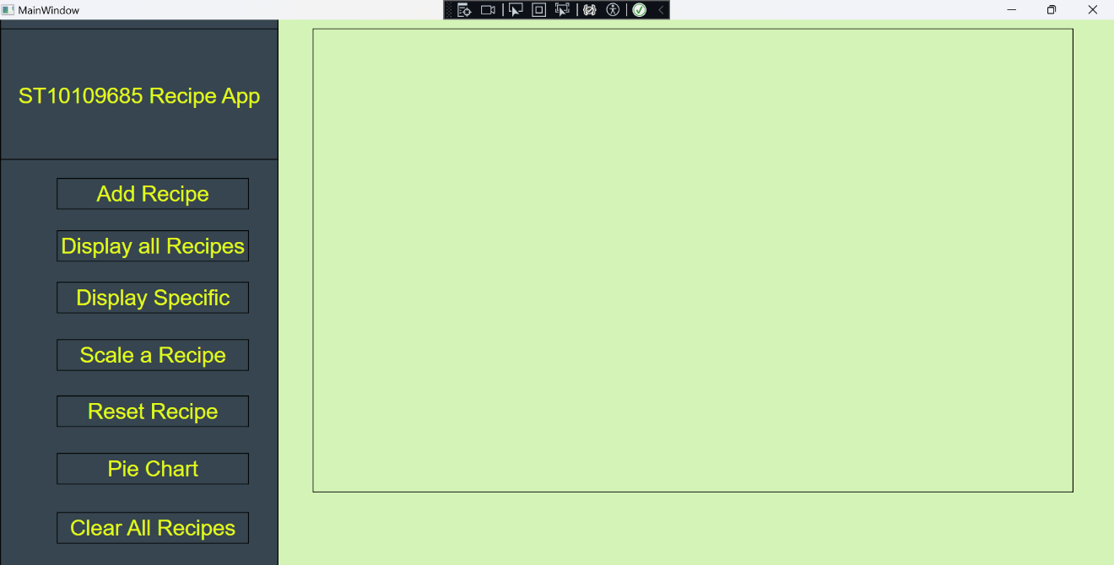application, they are greeted to the main window.

# Add Recipe Button

With nothing to display the user is given all these options. To start the user must click the Add Recipe button on the left side of the page.

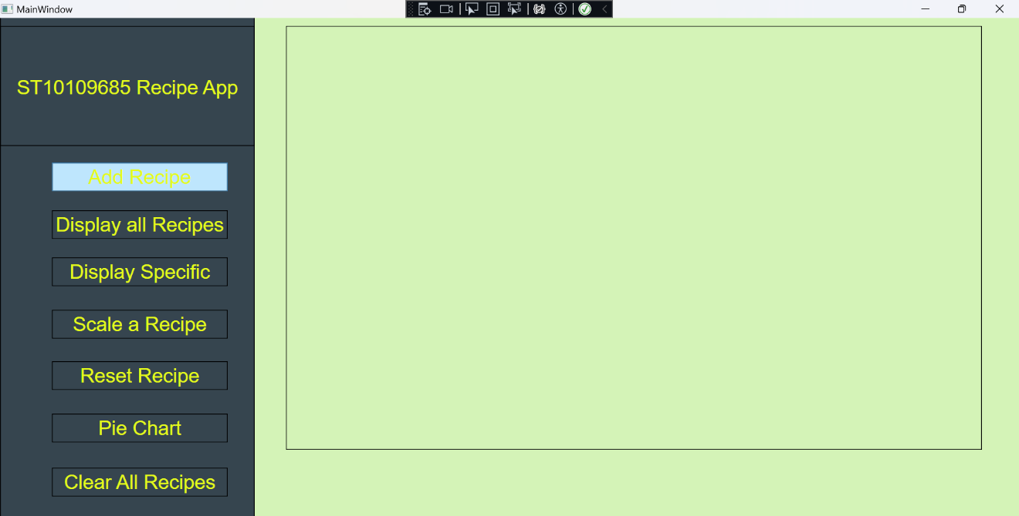

Next the user needs to add the following, Recipe Name, Ingredient Name, Quantity, Unit of Measurement, food Groups and Steps. Also, the Quantity and Calories only accepts numbers while the rest accepts everything.

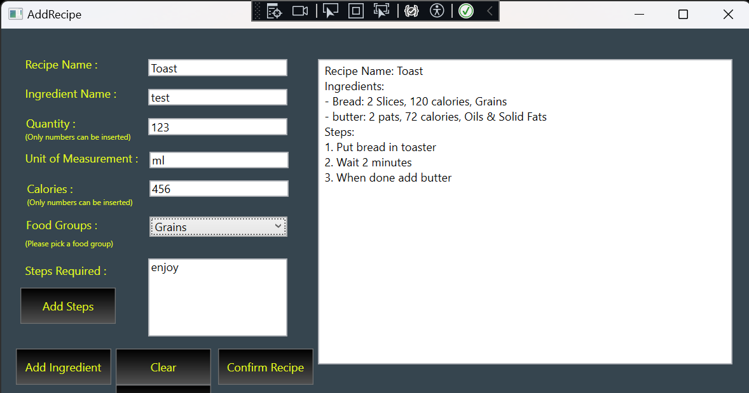

When the user clicks Confirm Recipe, they are brought back to the Home page with the Recipes they added to the list box.

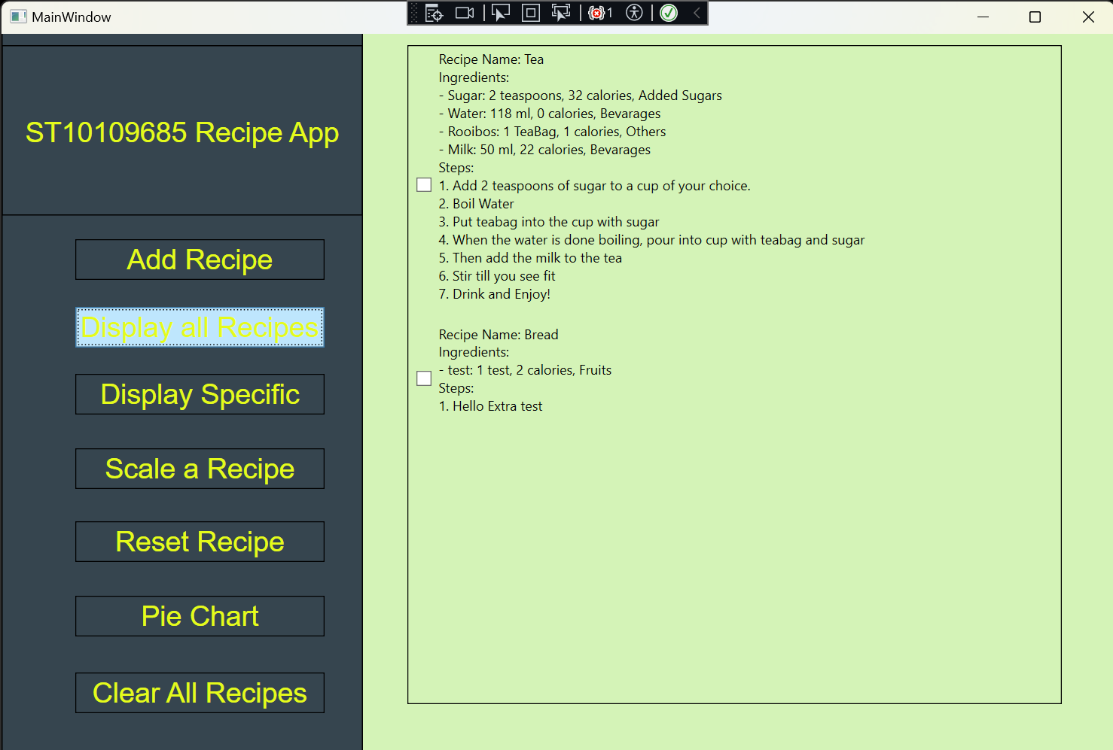

# Display All

The above picture is basically what will happen when clicking the display all recipe button.

# Display Specific

If the user has multiple recipes, they can click this button and can search for any recipe with that name.

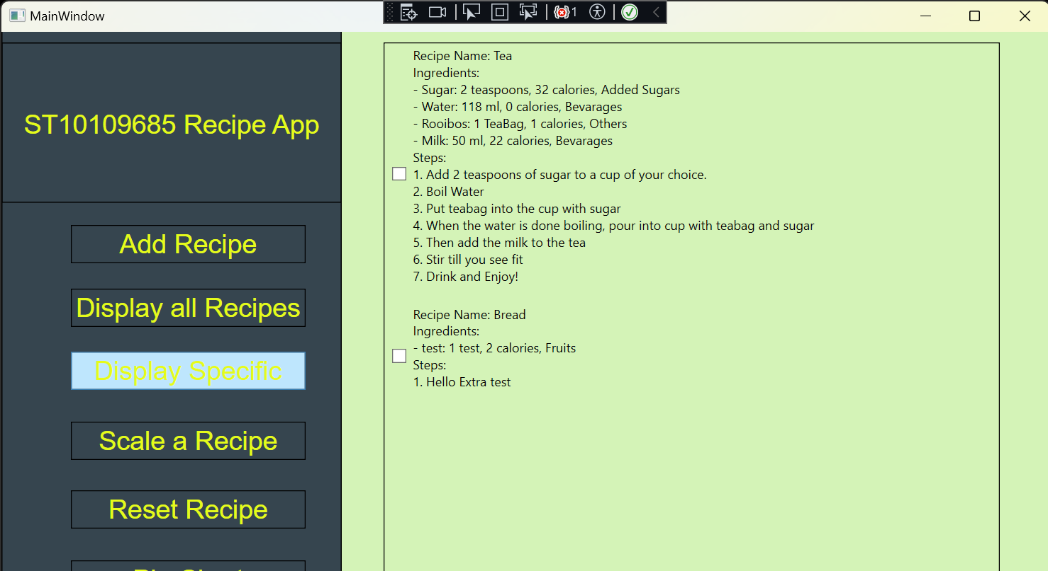

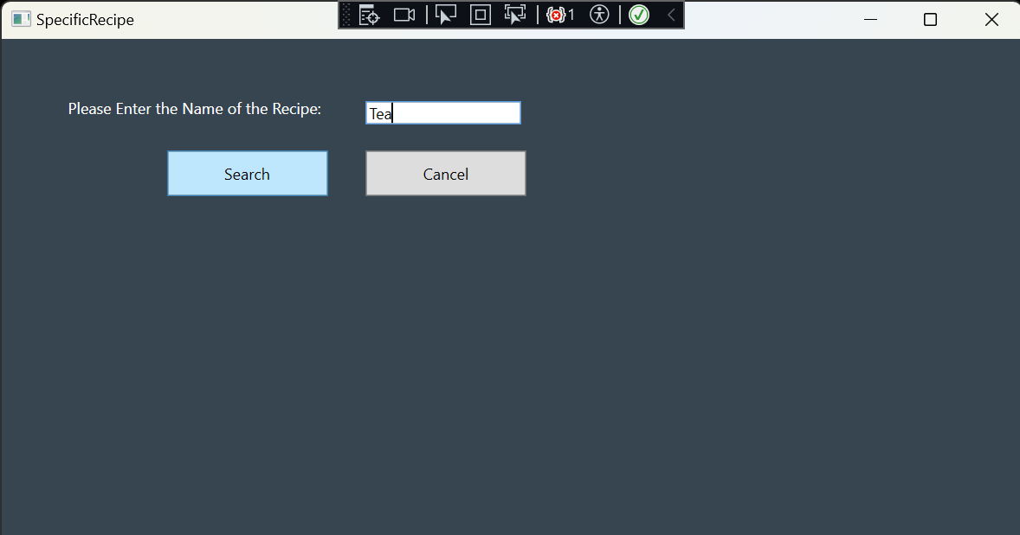

And when the recipe is found they are shown that specific recipe/recipes.

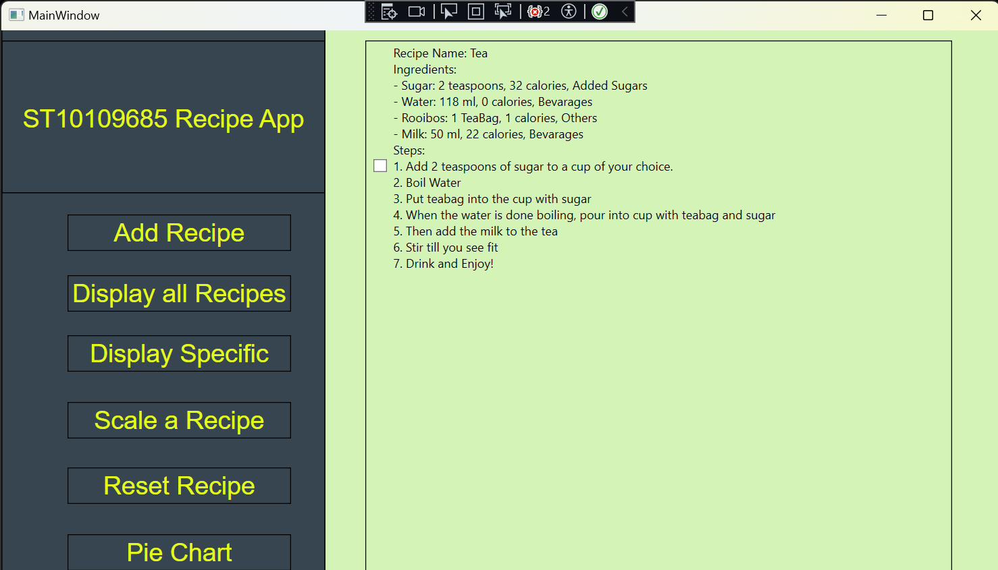

# Scaling

What if the user wants to increase the values of the quantity and Calories, well then, they just need to click onto “Scale a Recipe” button. Where they are given 3 options (0.5 half, 2 double, 3 triple). They first need to select which recipe they want to scale up or down.

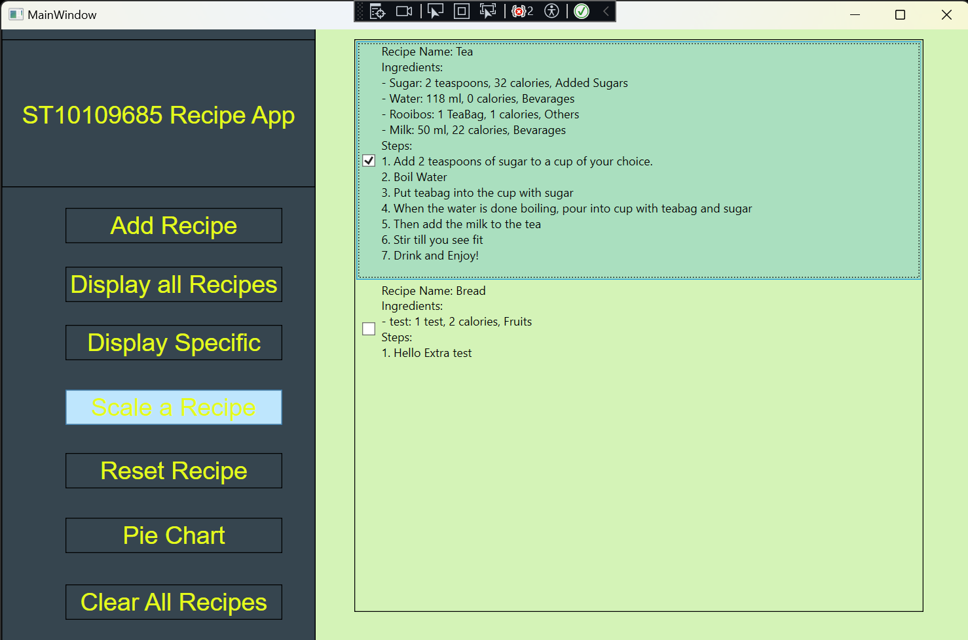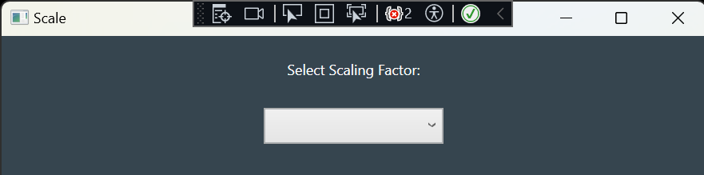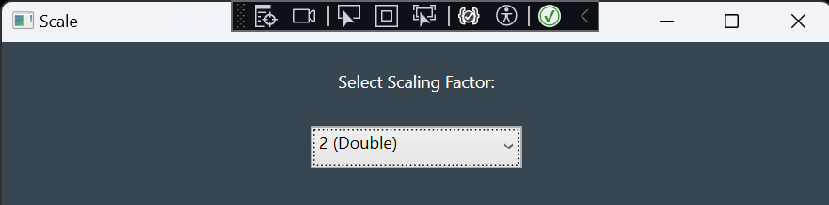

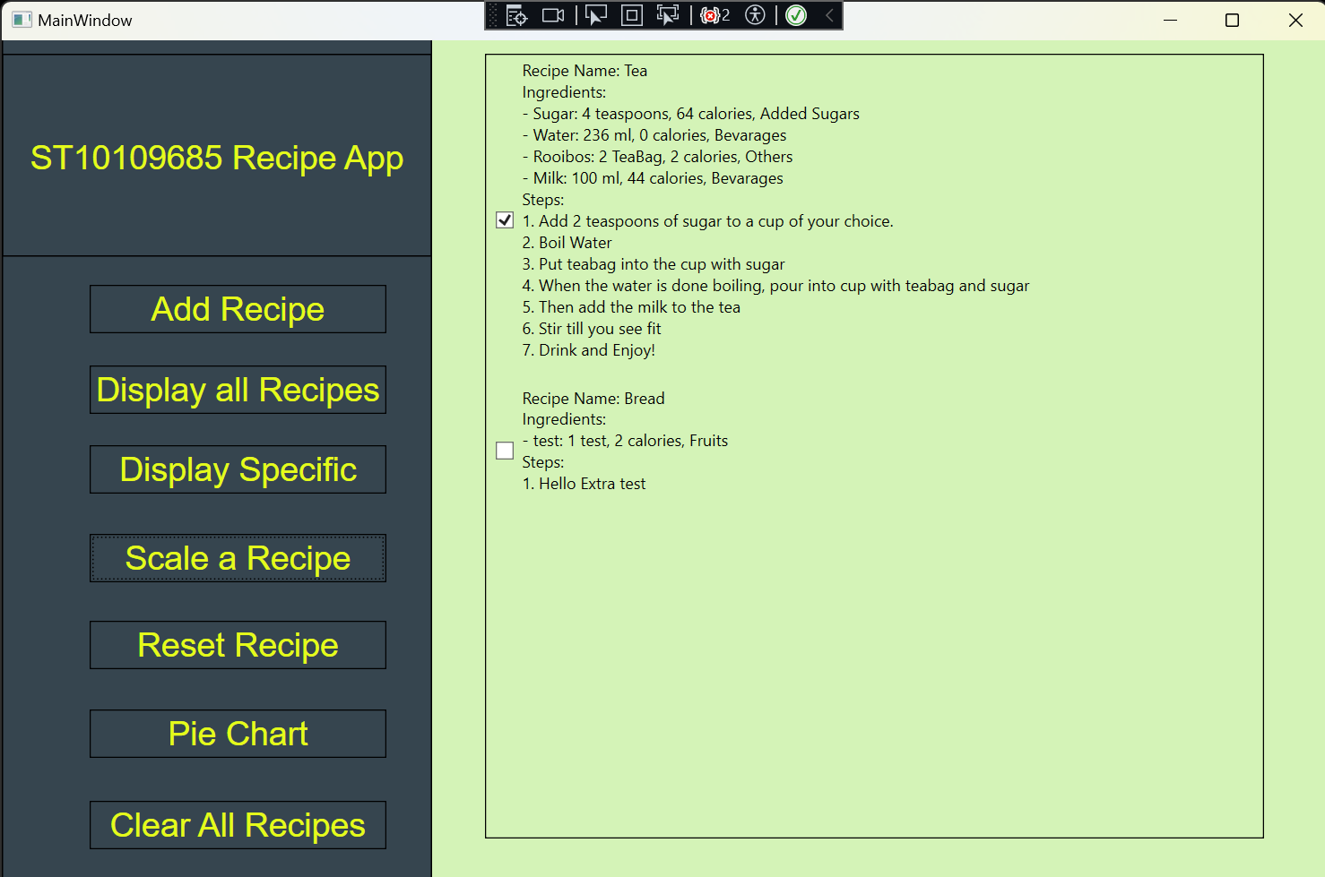

# Reset

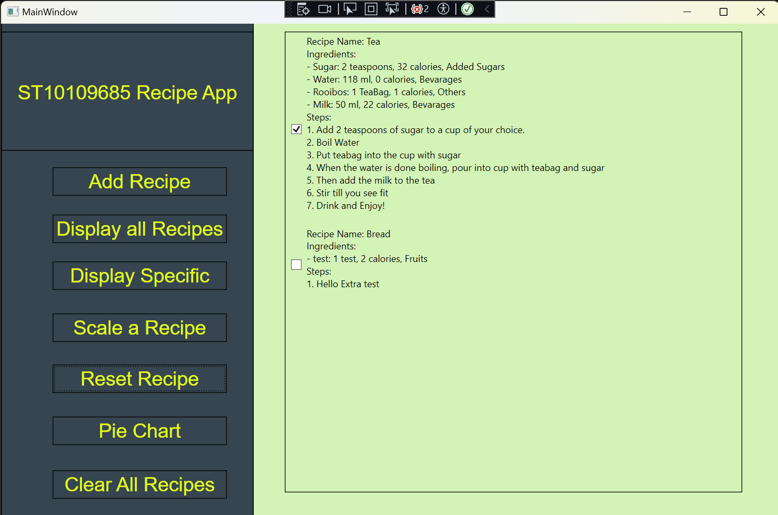If the user does not want to scale the recipe or made a mistake, they can always just press the Reset Recipe button. First, select the recipe they want to reset then press the button. 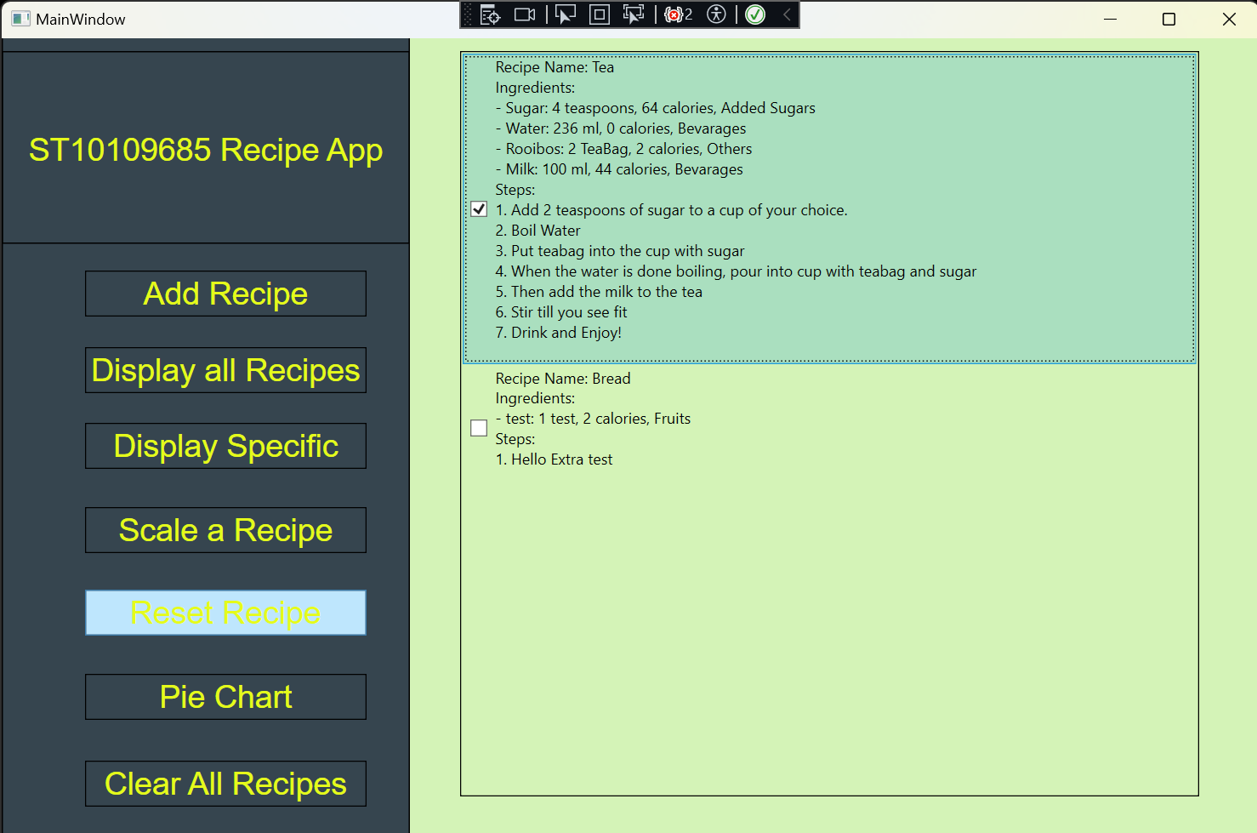

# Pie Chart

If the user wants to know how many foods groups, they have on the menu instead of pressing Display all Recipes and counting how many. They can press the Pie Chart button which will bring them to the pie chart window.

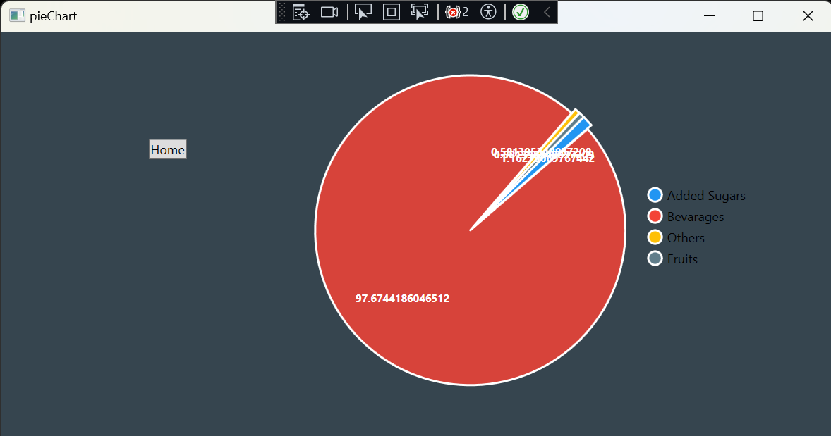

Press the home button to return to the Home Window.

# Clear All Recipes

Let’s say the user does not like the menu they can delete all records of the menu by pressing the “Clear all Recipes”.

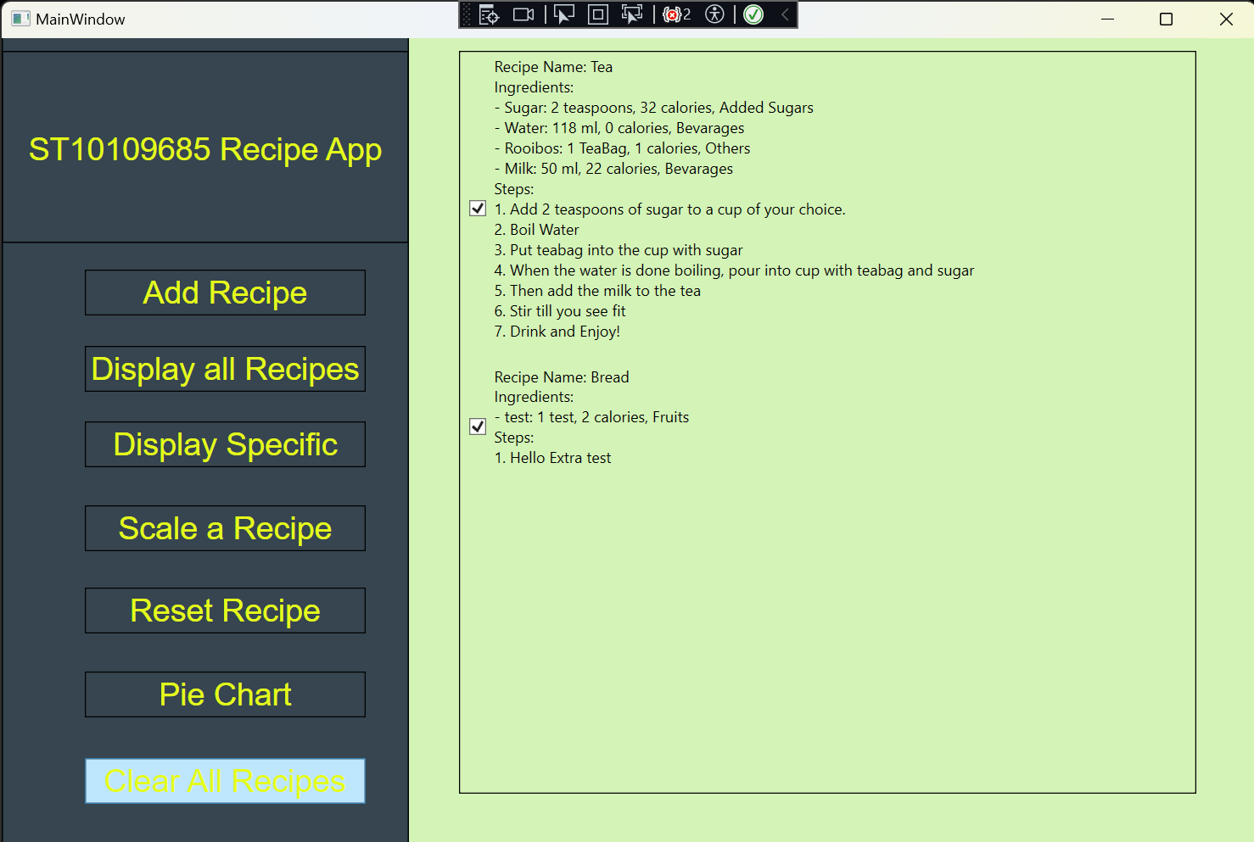

A Prompt will appear.

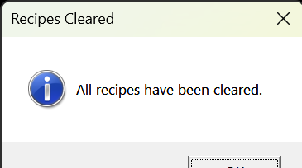

Then all the recipes have been deleted.

